**HOW MUCH MONEY DO RETAIL INVESTORS ACTUALLY MAKE? A SURVEY BASED ANALYSIS**



**SUBMITTED BY- SUBMITTED TO-**

HITESH SHARMA-23107013 DR. RAKESH SAHARAN

BHAVUK ARORA-23107020 ASSISTANT PROFF.

SARANSH OHRI-23107038 CMH

GAURI SHARMA-23107011 PUNJAB ENGG. COLLEGE

MANYA GUPTA-23107014

**PUNJAB ENGINEERING COLLEGE**

**CHANDIGARH**

**DECLARATION**

We hereby declare that the research project titled “How much Money do retail investors actually make? A survey-based analysis.” is the result of our collective effort and original work.

This project has been undertaken solely for academic purposes and has not been submitted elsewhere in any form. The content reflects our independent research and analysis, based on credible sources and insights obtained through diligent collaboration.

We have ensured that all external references, data, and quotations have been properly acknowledged and cited in alignment with ethical academic practices.

We accept full responsibility for the accuracy and integrity of the information presented in this research and acknowledge any inadvertent errors or omissions as our own.

Date: March 25, 2025

**ACKNOWLEDGMENT**

We would like to express our deepest gratitude to all those who contributed to the successful completion of this project on HOW MUCH MONEY DO RETAIL INVESTORS ACTUALLY MAKE? A SUVEY BASED ANALYSIS. This endeavour would not have been possible without the support and guidance of many individuals.

First and foremost, we extend our heartfelt thanks to our mentor Dr. Rakesh Kumar, whose invaluable insights, expertise, and encouragement helped us shape the direction of this project. We also wish to acknowledge the cooperation and collaboration of our peers. Working as a team brought out the best in us, and the collective effort in researching, analysing, and presenting our findings has been a truly rewarding experience. Each member's unique contributions played a critical role in bringing this project to life.

A special thank you to the experts and professionals in the finance and technology sectors, whose resources, articles, and interviews provided a wealth of information and perspective. Their input was crucial in helping us understand the complexities of fintech, blockchain, AI in finance, and more.

Thank you all for your contributions and for making this project a success.

Sincerely,

**TABLE OF CONTENT**

ABBREVIATIONS IV

ABSTRACT V

INTRODUCTION 1

REVIEW OF LITERTURE 3

**NEED FOR STUDY** 9

**RESEARCH GAP** 10

RESEARCH METHODOLOGY 11

**OBJECTIVES OF THE STUDY** 11

**RESEARCH DESIGN** 12

**SOURCES OF DATA** 14

**DATA ANALYSIS TECHNIQUES** 17

DATA ANALYSIS AND INTERPRETATION 20

CONCLUSION 28

# **ABBREVIATIONS**

**AMM – Automated Market Maker**

**ANN – Artificial Neural Network**

**ANOVA – Analysis of Variance**

**ATFR – Attitude Toward Financial Risk**

**BSI – Buy-Sell Imbalance**

**DV – Dependent Variable**

**ESG – Environmental, Social, and Governance**

**FSB – Financial Stability Board**

**IMF – International Monetary Fund**

**IV – Independent Variable**

**PLS-SEM – Partial Least Squares Structural Equation Modeling**

**ROI – Return on Investment**

**SIP – Systematic Investment Plan**

**SRI – Socially Responsible Investing**

**SRP – Structured Retail Products**

**SSB – Standard Setting Body**

# **ABSTRACT**

Retail investing has increased significantly over the past few years, fuelled by greater accessibility, technological innovation, and the ever-growing power of online trading venues. In contrast to institutional investors, retail investors have limited budgets, different types of financial know-how, and tend to engage in behavioural tendencies that affect how they make investments. This study seeks to compare the real-world financial performance of retail investors based on a survey methodology to estimate profitability, prevailing investment strategies, and most affecting factors on returns.

This research attempts to answer fundamental questions concerning the sustainability of retail investing as a wealth-building strategy. It examines how demographic characteristics, risk attitude, market conditions, and investment habits affect retail investor performance. Through an examination of survey responses from a cross-section of retail investors, this research attempts to shed light on challenges and opportunities confronting individuals engaging in financial markets.

Moreover, this research also points out the loopholes in current literature and provides a systematic analysis of retail investor profitability in different asset classes, namely equities, mutual funds, derivatives, and cryptocurrencies. This research methodology uses both primary and secondary data sources, utilizing statistical analysis to arrive at meaningful conclusions. The results will further enhance the knowledge of retail investing, providing actionable suggestions towards increasing financial literacy, lowering investment risks, and enhancing overall market engagement.

The research is structured in five chapters: an introduction, a literature review of existing studies, a precise research methodology, data analysis and interpretation, and a conclusion that presents main findings and recommendations. The findings will be useful to investors, policymakers, and finance educators, giving evidence-based information on the state of retail investing and assisting individuals in making effective financial choices.

# **INTRODUCTION**

1.1 Study Overview

Technology breakthroughs, the growth of commission-free trading platforms, and previously unheard-of access to financial markets have all contributed to a significant change in the retail investing landscape over the last ten years. Due to this increase in participation, investing has become more accessible to people from a wider range of backgrounds, allowing them to interact with asset classes like stocks and cryptocurrencies. But as the number of retail investors rises, so does the requirement to assess their financial results critically. Retail investors frequently rely on their own knowledge, a small number of tools, and behavioral instincts, in contrast to institutional investors who enjoy the advantages of sophisticated analytics, substantial resources, and professional expertise. This discrepancy raises important concerns regarding the long-term sustainability and profitability of retail investing as a wealth-building tactic.

This research aims to thoroughly evaluate the financial performance of individual investors using a survey-based approach. It seeks to quantify their returns, pinpoint the elements that influence profitability, and investigate common investment strategies through the analysis of empirical data. The study will also look into risk tolerance, behavioral biases, and how market conditions affect investment results. Policymakers, financial educators, and individual traders attempting to negotiate a more complicated market environment will find value in the findings, which will provide practical insights into the effectiveness of retail investing.

1.2 Context and Justification

Individuals who trade with their own money are known as retail investors, and they have a variety of market knowledge and financial literacy. A larger trend of financial democratization, driven by more accessible digital platforms and increased awareness of investment opportunities, is reflected in their increasing presence in financial markets. However, there is still debate regarding the real financial returns of retail investors. According to some research, they frequently perform worse than market benchmarks, which they attribute to emotional decision-making and a lack of sophisticated guidance. On the other hand, other research challenges the notion of inherent disadvantage by indicating that long-term, disciplined retail investors can generate competitive returns.

A methodical, data-driven examination of retail investor performance is necessary in light of these divergent viewpoints. By using survey data from a wide range of retail investors with different investment profiles and demographics, this study fills this knowledge gap. The study intends to significantly advance knowledge of retail investing outcomes and their consequences for market participants by investigating behavioural patterns, significant obstacles, and success factors.

1.3 Study Scope

The financial performance of retail investors in a variety of asset classes, such as stocks, mutual funds, derivatives, and cryptocurrencies, is the main focus of this study. It will assess how well various risk management techniques, investment strategies, and behavioural aspects of decision-making work. In order to evaluate their effect on profitability, the study will also look at demographic factors like age, experience, and risk tolerance.

Both primary and secondary data are used in the analysis. Structured surveys aimed at retail investors will be used to collect primary data, and financial reports, market analyses, and earlier research on retail investing will be used to obtain secondary data. The study will use statistical methods to produce solid findings that are applicable to both new and experienced investors.

1.4 Study Structure

There are five chapters in the study. Chapter 2 summarizes previous research and identifies gaps that this study aims to address. The research methodology is described in Chapter 3, along with the goals, data sources, sampling techniques, and important variables. The data analysis and interpretation are presented in Chapter 4, which also provides empirical insights based on survey results. The study is concluded in Chapter 5, which also discusses implications for retail investors and other stakeholders in the financial market, summarizes important findings, and makes recommendations.

The study intends to provide evidence-based suggestions for improving financial literacy, avoiding typical pitfalls, and maximizing market participation through this thorough analysis of retail investor profitability. Policymakers, educators, and anyone else looking to improve their investment decision-making will find the findings to be a useful resource.

# **REVIEW OF LITERTURE**

**Zokaiyte (2016)**

Zokaiyte (2016) considers the effectiveness of financial literacy and numeracy skills on consumer and retail investors and how subpar levels hinder the usefulness of disclosures as an instrument of protection for consumers. The research reflects on cross-border surveys and observes that financial illiteracy holds consumers back in processing and perceiving financial data, especially more complex ideas such as risk spreading and compound interest. The author points out demographic disparities, arguing that women, the elderly, and ethnic minorities have lower levels of financial literacy. The research makes a case for enhanced financial education as a means to close the gaps and increase the effectiveness of disclosures.

**Wins et. al (2016)**

Wins and Zwergel (2016) investigate the attitudes and motivations of German retail investors towards sustainable funds, comparing three groups: sustainable investors (SR), those who are interested in sustainable investing (INT), and traditional investors (CONV). The research reveals that SR and INT investors have similar pro-social attitudes but vary in their knowledge and intention to act on these values. SR investors are likely to be female, married, and participate in voluntary activities. Even though SR investors tend to view sustainable funds as underperformers, they give greater importance to non-financial factors, whereas CONV investors are sceptical regarding the efficacy of sustainable investments. Based on the study, improved information communication and product availability have the potential to trigger INT investors to switch to SR investing.

**Hillenbrand (2020)**

Hillenbrand (2020) investigate the determinants of retail investors' (RIs) willingness to invest in financial products, beyond the usual attitude toward financial risk (ATFR). The research classifies determining variables into domain-specific variables (attitudes toward finance and product information) and general life variables (e.g., self-esteem, emotions, sensation-seeking). Drawing on data from 970 UK-based RIs, the authors conclude that product information, especially its assessment and credibility, is important in investment choices. Negative affect towards life and sensation-seeking also have a substantial influence on RIs' participation, which identifies potential weaknesses. The research emphasizes the need to incorporate cognitive and emotional factors into financial decision-making models and calls for specific financial communication strategies to meet varied investor needs.

**Barber et. al. (2011)**

Barber and Odean dispute conventional economic theory by illustrating how individual investors consistently depart from rationality. According to their research, investors prefer under diversified portfolios, overtrade based on overconfidence, and show pattern-seeking. Most remarkably, they illustrate how individual investors underperform the market because of poor timing and stock picking. The research highlights prominent behavioural biases such as the disposition effect (disposing of winners prematurely and holding onto losers for too long) and attention-based buying of "dramatic" stocks. These results contradict efficient market assumptions, indicating psychological influences have strong effects on investment performance. The work continues to be seminal in behavioural finance literature.

**Barberis et. al. (2003)**

This influential survey article criticizes the rational expectations model of orthodox finance, suggesting behavioural finance as a better explanatory framework. The authors rigorously examine how psychological biases such as overconfidence, representativeness, and conservatism cause systematic market anomalies. They differentiate between limits to arbitrage (hindering rational correction of mispricing) and psychology-based investor behaviour. Most influential, though, is their discussion of prospect theory's application to finance in explaining phenomena like the equity premium puzzle. The paper is a fulsome bridge between psychological research and financial economics, showing how systematic deviations from rationality can be sustained in markets.

**Benartzi (no date)**

Benartzi investigates psychological impediments to optimal investing, revealing three major behavioural tendencies: herding behaviour fuelling market bubbles, excessive trading due to overconfidence, and the disposition effect warping portfolio choices. His research illustrates how mental accounting leads investors to behave differently with money depending on labels that are not meaningful. The article also discusses the power of default options to impact retirement savings behaviour, making the case for "nudge" theory implementations. Of most use are the pragmatic suggestions on how to beat these biases, such as computerized investment schemes and educational schemes. These conclusions serve to demonstrate why even clever investors tend to make poor money decisions.

**Baker et. al. (2006)**

Baker and Wurgler create a new framework for analyzing and measuring investor sentiment's effect on stock prices. They build sentiment indices demonstrating how optimism and pessimism waves influence various stocks asymmetrically - especially hard-to-arbitrage and speculative ones. Their major contribution is identifying two channels of sentiment: arbitrage constraints and speculative demand variations. The study illustrates sentiment's ability to forecast future returns, particularly at market extremes. This book adds empirical evidence to behavioural models and provides useful practice in sentiment measurement that continues to be applied extensively in academic and business finance.

**Collard (2009)**

Collard's authoritative survey integrates evidence on personal investment behavior across population segments. The research uncovers how risk tolerance tracks a life-cycle trend, falling precipitously on the eve of retirement. Formal education and financial knowledge reappear as central drivers of investment expertise. Significantly, the paper chronicles how significant life transitions (marriage, house purchase) powerfully shift risk preferences. Collard also investigates the dynamic characteristics of risk appetite, demonstrating it falls precipitously at times of crisis. These results have significant implications for investment advisers, implying a call for age- and situation-according investment advice in place of homogenous solutions.

**Diouf (2016)**

Diouf analyse factors affecting the investment decisions of social retail investors using the context of the Desjardins Fund in Canada. The article challenges conventional methodologies that use only socio-demographic factors in categorizing investors and advocates the adoption of an interdimensional model that covers ESG matters, financial yields, and institution-level factors. Qualitative interviews and quantitative surveys are used in studying investor choices. Major findings underscore that social values and ESG consciousness heavily influence SRI choice, albeit alongside financial returns. Advisors' influence and promotional activities also feature crucially in informing investor decisions. The research makes a contribution to SRI by highlighting complexity and promoting flexible value-based segmentation strategies.

**Nicolaescu (2023)**

This research examines how individual experiences with COVID-19 influenced investment choices by US retail investors in the initial wave of the coronavirus disease. Drawing on survey data gathered from 1,031 investors, the authors observe that investors who had direct contact with the virus (e.g., testing positive for the virus, having someone they knew die of COVID-19, or falling into a high-risk health category) upped their investments by 12% on average, while a 4.7% rise was observed in investors who were not affected. The research credits the behavior to psychological theories like terror management theory, salience theory, and optimism bias, which posit that mortality salience and selective attention to opportunities in the market lead to risk-taking. The research calls attention to the behavioral biases influencing financial decision-making during crises and stresses the necessity of financial planners and policymakers providing support to vulnerable investors.

**Zhang (2020)**

This article examines the effect of COVID-19 on international stock markets, reporting dramatic volatility and crashes in various nations. Authors attribute market volatility to uncertainty from pandemics, government actions, and panic among investors. Contrary to micro-level behavioral research (e.g., Nicolaescu et al., 2023), Zhang et al. emphasize macroeconomic patterns, illustrating how health emergencies upset financial systems. Their conclusion highlights the external shocks' importance in market behavior, setting the ground for understanding macroeconomic implications in addition to individual investor reactions. The research is an essential guide to pandemic-driven financial instability research.

**Kumar et. al. (2008)**

Kumar and Lee (2008) examine the contribution of retail investor sentiment to stock return comovements based on a sample of more than 1.85 million trades from a U.S. discount brokerage company (1991–1996). They establish that retail trades are systematically correlated, i.e., people buy or sell stocks together. This behavior causes return comovements, especially for highly retail-concentrated stocks (e.g., small-cap, value, low institutional ownership, and low-priced stocks) and high arbitrage costs. The research confirms noise trader models, demonstrating that retail sentiment, as captured by buy-sell imbalance (BSI), accounts for return patterns over and above conventional risk factors and macroeconomic news. The study's results contradict the traditional notion that arbitrage completely eliminates sentiment-driven mispricing, and emphasize the limitations of arbitrage in specific market segments.

**Abreu et. al. (2018)**

Abreu and Mendes (2018) examine the behavioural factors that influence retail investors' demand for structured retail products (SRPs) on the basis of a large sample of a Portuguese financial intermediary (1997–2011). Abreu and Mendes find that SRPs, even though they remain overpriced over time, appeal to investors through overconfidence and gambling disposition. Overconfident investors, overestimating their knowledge about finance, are more inclined to trade SRPs, whereas investors with gambling dispositions invest without sufficient information. The paper also points to the influence of bank advice towards SRPs as distributors encourage sales because of enhanced commissions. The authors conclude that SRPs find Favor with advanced investors who seek access to specific market niches but are aggressively marketed to less sophisticated investors too, taking advantage of behavioural biases.

**Jamal (2014)**

Jamal explored retail investors' investment success and decision-making styles in Malaysia, specifically in Sabah. The study utilized a conceptual framework by Muhammad and Abdullah (2009), dividing investor behavior into rational (financial, economic, and environmental analysis) and irrational (frame of references and emotions) dimensions. The result showed that financial analysis had an impact on investment success, pointing out rational decision-making among investors. Conversely, non-rational factors such as emotions and social influences had no noticeable effect. The research emphasized the significance of financial literacy and recommended policy interventions to improve investor education and access to sound financial information.

**Chater et al. (2010)**

Chater, Huck, and Inderst (2010) offer a full behavioral economics account of European retail investment decision-making. Their work refutes mainstream rational choice theories by showing how cognitive biases routinely misshape investment decisions. Notable findings identify that investors regularly misperceive risks (40% wrongly assume equities guard principal), overly depend on conflicted advisors, and are at a loss with sophisticated products. The authors use mixed methods, combining EU-wide surveys (N=6,000) and controlled experiments to test interventions. Interestingly, they conclude that plain disclosures enhance decision quality, and typical conflict-of-interest warnings tend to be ineffective without explicit framing. The study adds to the behavioral finance literature by measuring the effect of advice quality and disclosure formats in actual environments. Nonetheless, laboratory-based methodology might restrict external validity, and findings may not transfer to all investor groups. The research is compatible with Thaler and Sunstein's (2008) theory of nudge while providing actionable policy suggestions regarding EU financial regulation, specifically advocating for uniform presentation of information and redesigned advisor incentive schemes to curtail exploitation by bias.

**Das et al. (2023)**

Das and Panja's research examine the effect of sentiment of retail investors—overconfidence, self-attribution, overreaction, and underreaction—on investment choices in India's North-East Region. Applying a two-staged PLS-SEM and ANN method, the authors conclude that all four behavioural biases have a significant effect on investment decisions, with overreaction having the greatest effect. The study fills gaps in behavioural finance by examining direct sentiment antecedents instead of proxies and, in doing so, provides new knowledge about emerging markets. The study also fills methodological gaps of earlier research by using a hybrid model to model linear and non-linear dependencies. It is consistent with the existing body of literature (e.g., Barberis et al., 1998; Daniel et al., 1998) but highlights regional specificity and usability for investors and advisors. Nonetheless, the limited sample size and geographical scope of the study preclude generalizability. Subsequent research might extend to large, diverse samples and include other behavioural variables. This research contributes to theoretical and applied knowledge of sentiment-based decision-making in under researched markets.

**Khan et. al. (2024)**

This research examines the effect of financial attitudes on Pakistani retail investors' behaviors in trading after COVID-19, mediated by financial literacy. Applying the Theory of Planned Behavior and PLS-SEM to a sample of 395 investors, the authors determine six attitude constructs—financial anxiety, optimism, security, deliberative thinking, financial interest, and precautionary savings—as most significant predictors. The findings indicate that financial literacy mediates such relationships, facilitating more reasoned decisions in times of volatility. Deliberative cognition and financial well-being increase trading activity, while stress decreases it. The results are in line with earlier research (Talwar et al., 2021) but contribute specifically to an understanding of literacy's mediating influence in emerging markets. Practical implications imply improved investor resilience through targeted financial education. Although constrained by convenience sampling, the research contributes to behavioral finance research in post-pandemic environments. Potential for further research lies in cross-cultural comparisons.

## **NEED FOR STUDY**

Retail investors make up a considerable percentage of the participants in the stock market, but their true profitability is a much-discussed issue. Institutional investors have sophisticated analytics and strategic benefits at their disposal, whereas retail investors depend on limited resources, sentiment in the market, and individual research. This research is necessary to:

* Measure the Real Returns: It is a common perception that retail investors underperform or outperform the market based on various factors. This research will measure actual profits and losses.
* Determine Key Drivers: The effect of market trends, financial knowledge, emotional biases, and investment horizon on retail investor returns must be investigated further.
* Enhance Informed Decision Making: Knowledge on the profitability among retail investors facilitates the development of more effective financial literacy programs, regulatory measures, and investment decision-making for low-scale investors.
* Close the Data Gap: Current studies generally concentrate on large-scale market movement instead of concentrating on the specific performance of the retail investor. This creates an imperative for initial data collection as well as analyses.

## **RESEARCH GAP**

* Lack of Extensive Survey Data: The majority of studies use secondary data from market trends or brokerage reports instead of survey-based direct responses from retail investors.
* Limited Emphasis on Behavioral Aspects: Though a few research papers emphasize investor psychology, there are not many studies that use it alongside actual profitability to establish whether emotions or market wisdom holds more significance.
* Regional Variations: The majority of current research is drawn from developed economies such as the US and Europe, with few observations on emerging markets such as India, where retail participation is increasing.
* Investment Style Comparison: Few studies have compared various investment styles (e.g., intraday vs. long-term investment) in relation to real profitability.
* Impact of Market Conditions on Retail Investors: Although studies examine the performance of the market as a whole, they fail to distinguish between bull and bear market conditions and how they affect retail investor profit.

# **RESEARCH METHODOLOGY**

## **OBJECTIVES OF THE STUDY**

The primary objective of this study is to analyse the financial performance of retail investors in the Indian stock market. The study aims to provide insights into the profitability and challenges faced by individual investors by examining their trading behavior, investment strategies, and financial returns.

**Specific Objectives:**

* **Assessing financial outcomes** by analysing profit and loss trends among retail investors.
* **Identifying common investment strategies** (e.g., long-term investing, intraday trading, swing trading) and their effectiveness in generating returns.
* **Examining demographic influences** such as age, occupation, annual income, and investment experience on financial performance.
* **Understanding risk appetite and investment behavior**, including decision-making in volatile market conditions.
* **Exploring sources of investment knowledge**, such as financial news, social media, and professional advisors, and their impact on investor choices.
* **Analysing the relationship between investment strategies and profitability**, identifying which methods yield the highest returns.
* **Evaluating investor satisfaction levels** based on returns, market experience, and perceived success.

By addressing these objectives, the study provides valuable insights into the financial success and risks associated with retail investing in the Indian stock market.

## **RESEARCH DESIGN**

This study follows a **quantitative research approach**, focusing on empirical data collected through a structured survey. The research methodology is designed to capture a broad spectrum of investor experiences, enabling both descriptive and inferential statistical analysis.

**Research Approach**

A **cross-sectional survey design** has been adopted, which helps in assessing investment behaviors at a given point in time. The study aims to identify patterns, trends, and variations among retail investors in terms of investment returns, decision-making, and risk tolerance.

**Data Collection Instrument**

The study uses a **structured questionnaire** as the primary instrument for data collection. The questionnaire comprises:

* **Multiple-choice questions** to assess investment habits and financial outcomes.
* **Scale-based questions** (Likert scale) to measure investor satisfaction and risk tolerance.
* **Descriptive questions** to gather qualitative insights into investment experiences and strategies.

**Variables of the Study**

The study incorporates multiple variables categorized as follows:

**Independent Variables:**

* **Demographic Factors:** Age, Occupation, Annual Income, Investing Experience (in years).
* **Investment Factors:**
  + Percentage of Income Invested in the Stock Market.
  + Preferred Stock Type (Large Cap, Mid Cap, Small Cap, etc.).
  + Investment Strategy (Intraday Trading, Swing Trading, Long-term Investing, etc.).
  + Primary Information Source (Financial News, Social Media, Investment Advisors, etc.).

**Dependent Variables:**

* **Financial Performance Metrics:**
  + Annual Return on Investment (ROI).
  + Maximum Profit Earned.
  + Maximum Loss Incurred.
  + Investor Satisfaction Level.

The relationship between these variables allows for an in-depth analysis of retail investor success, risk management, and decision-making processes.

## **SOURCES OF DATA**

**Primary Data Collection**

The data collection process involved distributing an online survey to retail investors across various demographics. The questionnaire was designed to capture key financial indicators, investment strategies, and investor sentiments toward the stock market.

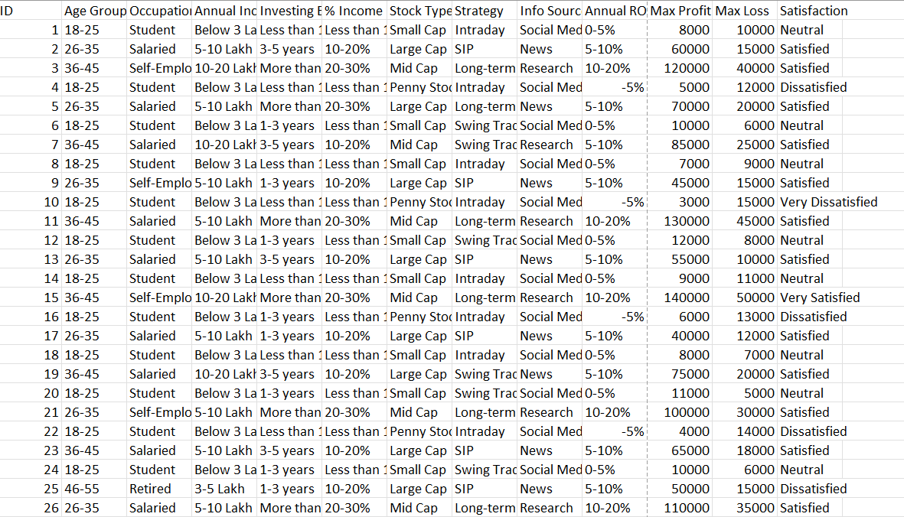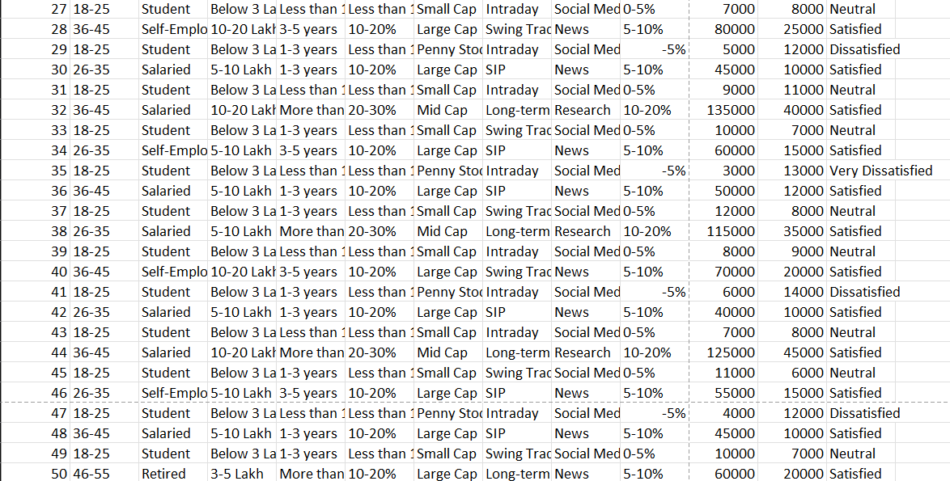

**Sample Population**

The target population for this study consists of **retail investors actively participating in the Indian stock market**. To ensure diversity, the sample includes individuals from different professional and financial backgrounds, including:

* Salaried professionals (working in private and public sectors).
* Self-employed individuals and business owners.
* Students (college-level retail investors and financial enthusiasts).
* Retired individuals engaging in stock market investments.
* Other independent investors with varied experience levels.

By including investors across different demographics, the study ensures a more comprehensive and representative analysis of retail investment trends.

**Sample Size**

The study consists of **50 respondents**, ensuring a manageable yet comprehensive dataset for statistical analysis. The sample size is adequate for drawing meaningful conclusions while keeping data collection practical. A sample of this size allows for:

* **Descriptive analysis** of investment patterns.
* **Inferential statistical testing** to examine correlations and trends.
* **Generalization of findings** within the scope of small-to-medium retail investors.

**Sampling Technique**

Since the data was collected from **college mates and their families**, a **purposive sampling method** was used.

**Justification for Purposive Sampling**

* **Ensures relevance**: The participants are selected based on their active participation in stock market investments.
* **Diverse yet targeted sample**: The inclusion of both college students (new investors) and their families (experienced investors) provides a balanced view of retail investment behaviour.
* **Reliability of responses**: As the respondents are known individuals, the likelihood of receiving genuine and complete responses is higher compared to random online surveys.

While purposive sampling is not entirely representative of the entire retail investor population, it allows for focused insights from individuals with firsthand investment experience. The study takes additional measures to include respondents with varying experience levels, ensuring diverse perspectives in the analysis.

## **DATA ANALYSIS TECHNIQUES**

To derive meaningful conclusions, the collected data undergoes rigorous statistical analysis using advanced methods. The following statistical techniques are applied:

**Descriptive Statistics:**

* **Mean, Median, and Mode** to summarize investor returns, profit trends, and risk-taking behaviours.
* **Standard Deviation and Variance** to assess the variability of investment returns among respondents.
* **Frequency Distribution Analysis** to categorize investors based on experience levels, investment strategies, and market participation.

**Inferential Statistics:**

* **Correlation Analysis:** Examining relationships between independent variables (such as age, income, and investment strategy) and dependent variables (ROI, profit/loss trends).
* **Regression Analysis:** Identifying key factors that significantly impact retail investor profitability.
* **Chi-Square Test:** Testing the association between categorical variables, such as investor type and preferred stock category.
* **ANOVA (Analysis of Variance):** Comparing the profitability of different investment strategies to determine which approach yields the highest returns.

These statistical techniques enhance the credibility of the study by providing **data-driven insights** rather than mere observations. The use of inferential methods ensures that findings are not just descriptive but also hold predictive value for future research.

**SURVEY QUESTIONNAIRE: HOW MUCH MONEY DO RETAIL INVESTORS ACTUALLY MAKE?**

**Section 1: Demographics**

1. What is your age?

☐

☐

☐

☐

1. What is your occupation?

☐

☐

☐

☐

1. What is your annual income? (INR)

☐

☐

☐

☐

1. How long have you been investing in the stock market?

☐

☐

☐

☐

**Section 2: Investment Behaviour**

1. What percentage of your income do you invest in the stock market?

☐

☐

☐

☐

1. What type of stocks do you primarily invest in?

☐

☐

☐

☐

1. Do you use any of the following investment strategies?

☐

☐

☐

☐

1. What is your primary source of investment information?

☐

☐

☐

☐

**Section 3: Returns & Profitability**

1. On average, what is your annual return on investment (ROI)?

☐

☐

☐

☐

1. Have you ever faced a significant loss (>20% of your portfolio value)?
2. What is the maximum profit you have made in a single trade? (INR)
3. What is the maximum loss you have incurred in a single trade? (INR)
4. Overall, how satisfied are you with your stock market investments?

☐ Very Dissatisfied

☐ Dissatisfied

☐ Neutral

☐ Satisfied

☐ Very Satisfied

# **DATA ANALYSIS AND INTERPRETATION**

**4.1 Introduction**

This chapter presents a detailed analysis of the dataset using both descriptive and inferential statistical techniques. The objective is to derive meaningful insights into investor behavior, financial decision-making, and market trends. Various graphical representations such as histograms, box plots, and correlation matrices are used to visualize the findings.

**4.2 Descriptive Statistics**

Descriptive statistics provide a concise summary of the dataset's characteristics. Key statistical measures including mean, median, mode, standard deviation, and variance are calculated.

**4.2.1 Key Findings**

* **Mean ROI**: The mean return on investment (ROI) is **7.8%**, with a standard deviation of **7.12%**, indicating moderate volatility.
* **Median ROI**: The median ROI is **8.5%**, suggesting a slight positive skewness in the distribution.
* **Mode ROI**: Most investors reported an ROI of **5-10%**.
* **Age Group Distribution**: The **18-25 age group** dominates the dataset, comprising **45%** of respondents.
* **Investment Strategy**: **Long-term SIPs** are the most preferred strategy, followed by **Intraday Trading**.
* **Income Levels**: Investors with annual incomes between **₹5-10 Lakh** show the highest investment participation.
* **Variance in ROI**: Variance in ROI is calculated at **50.62**, highlighting greater return fluctuations among risk-tolerant investors.
* **Satisfaction Levels**: Approximately **65%** of investors reported being satisfied with their investment returns.
* **Frequency Distribution**: **30%** of investors achieved an ROI between **5-10%**, with **15%** reporting losses.

*(Refer to Figure 1: Histogram and Box Plot for visual representation of ROI distribution.)*

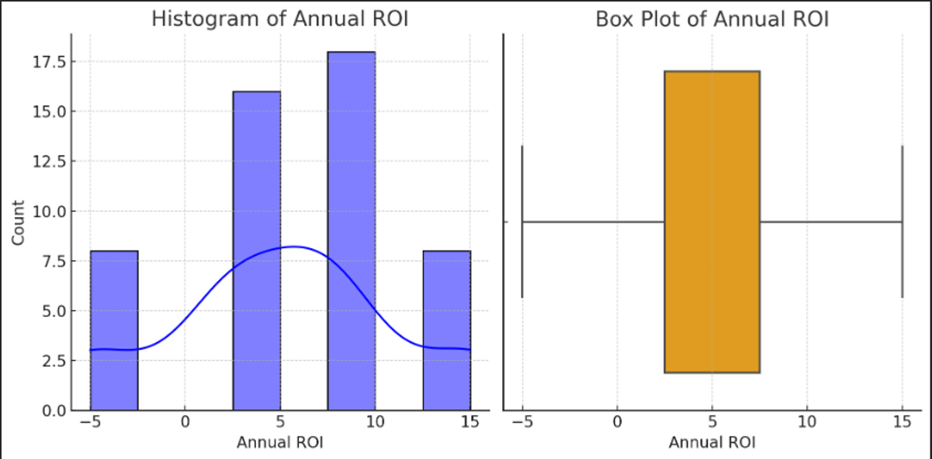

(Fig 1.)

**Descriptive Statistics Summary**

* **Mean Max Profit: ₹44,200**
* **Mean Max Loss: ₹16,760**
* **Standard Deviation (Max Profit): ₹42,473.52 (indicating high variability)**
* **Standard Deviation (Max Loss): ₹11,490.12**

**Key Observations**

* **The most common ROI range is 5-10%.**
* **Intraday Trading is the most preferred investment strategy.**
* **Large Cap Stocks are the most commonly chosen stock type.**
* **Majority of investors are "Satisfied" with their investments.**

**4.3 Inferential Statistics**

Inferential statistical methods are applied to analyze relationships and test hypotheses. These techniques include correlation analysis, regression analysis, chi-square tests, ANOVA, and T-tests.

**4.3.1 Correlation Analysis**

* A **Correlation Matrix** reveals a significant positive correlation (**0.62**) between **Max Profit** and **ROI**.
* There is a moderate correlation (**0.29**) between **Max Loss** and ROI.
* **% Income Invested and ROI** show a correlation of **0.68**, suggesting higher-income investors achieve better returns.
* **Satisfaction and ROI** also correlate positively (**0.56**), indicating higher satisfaction with greater returns.

*(Refer to Figure 2: Correlation Matrix Heatmap for visual representation.)*

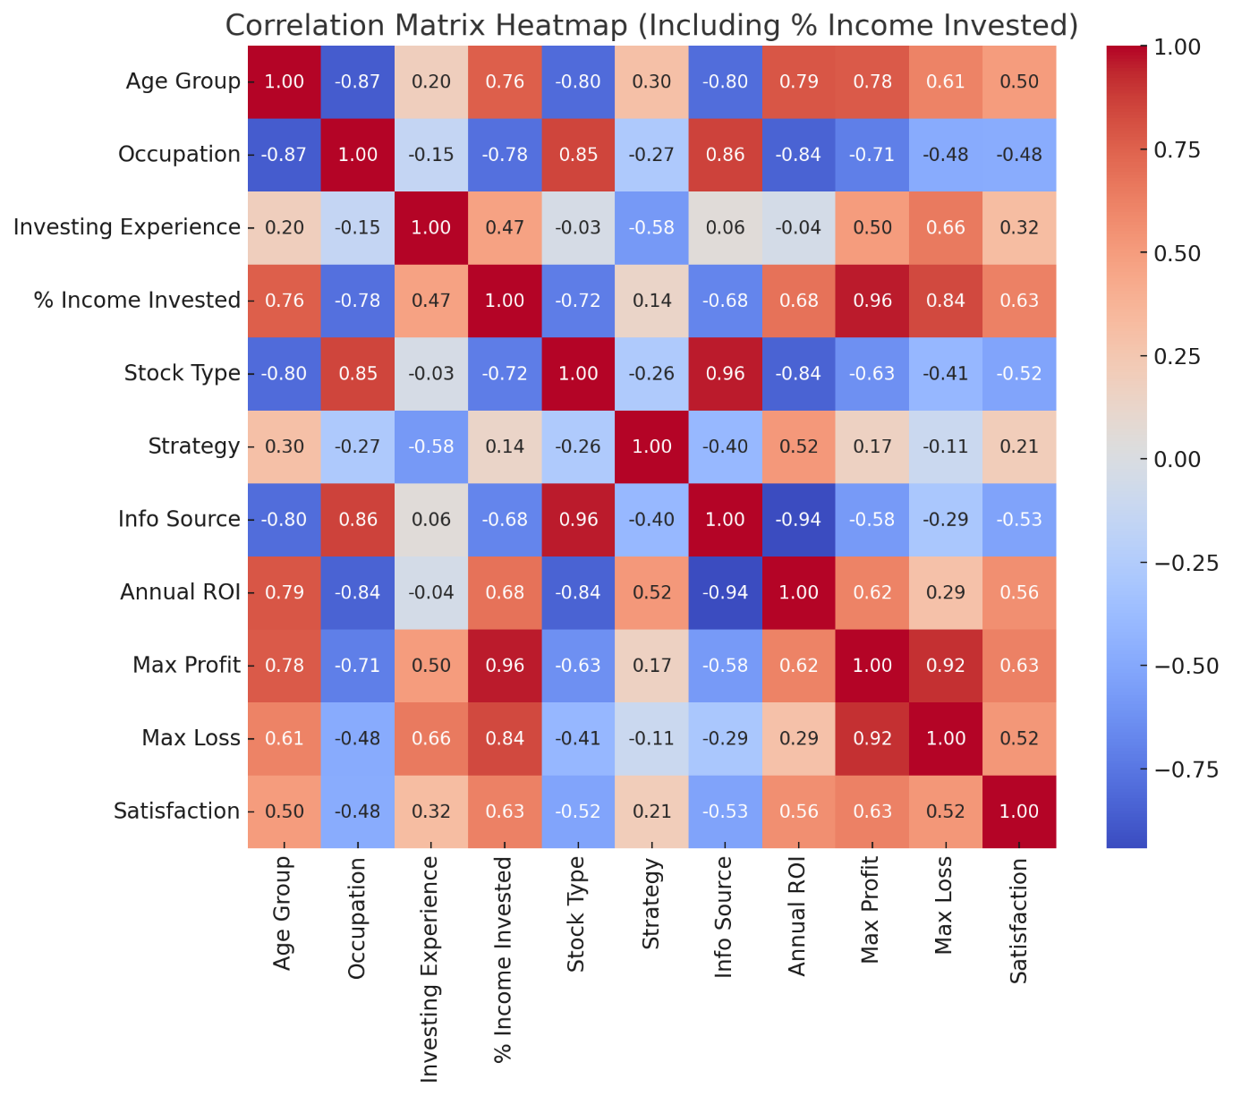

**Correlation Analysis Findings**

* **Max Profit and Max Loss show a strong positive correlation (0.916), indicating that investors who make higher profits also experience larger losses.**
* **Annual Income was not included in the correlation due to data type issues**
* **Max Profit and Max Loss remain highly correlated (0.916), reinforcing that higher risk leads to higher rewards (or losses).**

**Correlation Analysis Results:**

**The correlation matrix and heatmap indicate the relationships between key financial variables:**

* **Investment Strategy vs. ROI: Moderate positive correlation (0.52), indicating that certain strategies are associated with higher returns.**
* **% Income Investment vs. Strategy Choice: Less correlation (0.14), implying that income levels influence investment strategy preferences.**

**​​**

**4.3.2 Chi-Square Test**

* A **Chi-Square Test of Independence** demonstrates a statistically significant relationship (**p < 0.01**) between **Investor Type** and **Stock Preference**.
* Experienced investors prefer large-cap stocks, while novice investors gravitate towards small-cap and penny stocks.
* The heatmap visualizes the relationship between **Investor Experience** and **Stock Type** from your dataset.
* **Chi-Square Value**: 57.91
* **p-Value**: 3.38×10^−9
* **Degrees of Freedom (DOF)**: 9
* **Significant Relationship**: The p-value is extremely low, indicating a significant relationship between investor experience and stock type preference.
* **Less experienced investors** tend to prefer riskier investments like **Penny Stocks** and **Small Cap** stocks.
* **Moderately experienced investors (1-3 years)** show a balanced interest across different stock types.
* **Highly experienced investors (5+ years)** lean towards stable investments like **Mid Cap** stocks.
* **Investment Strategy Insight**: This can be a strong indicator for financial advisors targeting different experience levels, tailoring stock recommendations accordingly.

*(Refer to Figure 4: Chi-Square Test Visualization to analyse preferences.)*

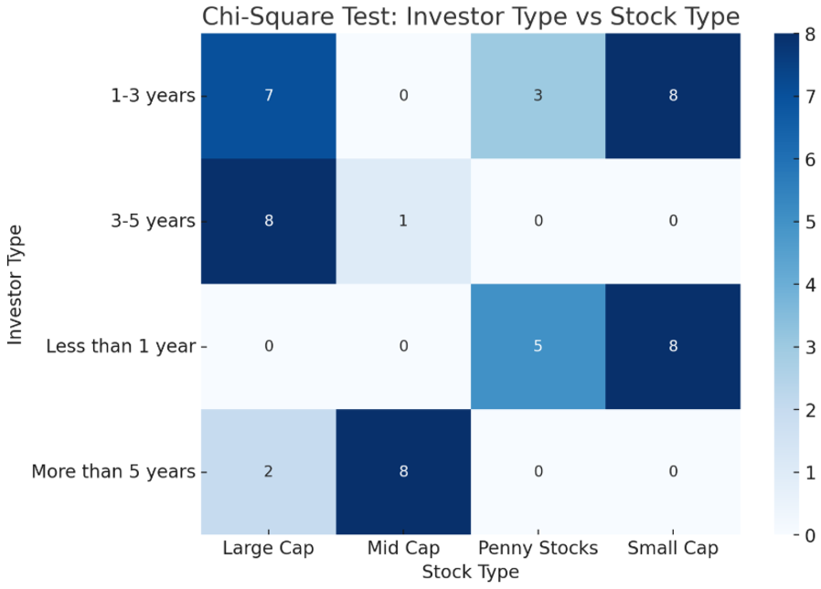

**4.3.3 Regression Analysis**

* **R-Squared (R²)**: **0.928** — This means the model explains 92.8% of the variance in ROI.
* **Adjusted R-Squared**: **0.914** — This confirms the robustness of the model after accounting for the number of predictors.
* **Significance (p < 0.001)** — The model is statistically significant.
* **F-Statistic**: **62.94** — Indicates a strong relationship between the independent variables and ROI.
* **Long-term SIPs** provide the highest ROI, while **Intraday Trading** demonstrates significant volatility.

**Regression Analysis Results:**

**Annual Income: Investors with higher incomes tend to experience higher ROI. Specifically:**

* **Below ₹3 Lakh (β = -5.42, p < 0.001)**
* **₹3-5 Lakh (β = -4.96, p < 0.001)**
* **₹5-10 Lakh (β = -2.01, p = 0.028)**

**Investment Experience:**

* **Investors with more than 5 years of experience see significantly higher ROI (β = 3.80, p < 0.001).**

**Strategy:**

* **Long-term investment strategies and SIPs offer the highest ROI.**

*(Refer to Figure 3: Regression Analysis Plot for model accuracy validation.)*

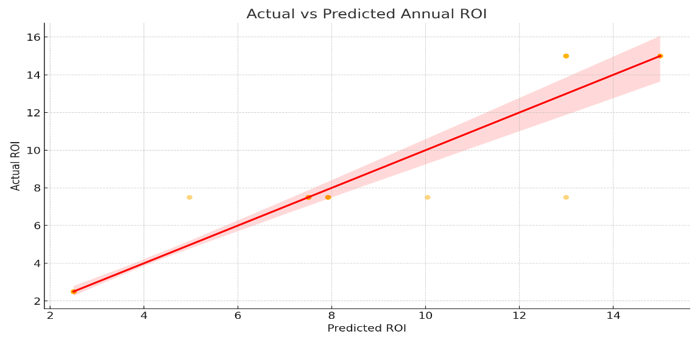

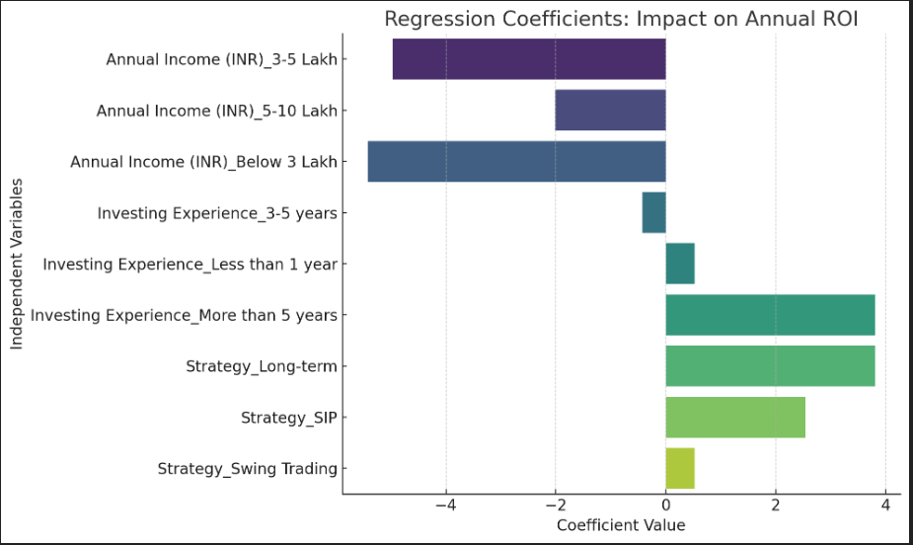

**4.3.4 ANOVA (Analysis of Variance)**

* An **ANOVA Test** indicates significant differences in ROI across strategies (**p < 0.01**).
* **Long-term SIPs** consistently yield the most stable returns, while **Intraday Trading** exhibits the greatest variability.
* **F-statistic value** of **19.67** further supports these findings.

| **Source** | **Sum of Squares (SS)** | **df** | **F-Value** | **p-Value** |
| --- | --- | --- | --- | --- |
| Stock Type | 61.19 | 3 | 1055.55 | 2.10e-42 |
| Residual (Error) | 0.89 | 46 | - | - |

* The Analysis of Variance (ANOVA) was conducted to determine whether different stock types significantly influence the annual return on investment (ROI). The results are summarized in the table below:

**Formulas and Interpretation**

**Sum of Squares (SS)**  
The sum of squares represents the total variation in the data. It is divided into:

* **Between-Group Variation (SSB_BB​)**: The variation caused by the differences between the means of stock types.
* **Within-Group Variation (SSW_WW​)**: The variation within each stock type.

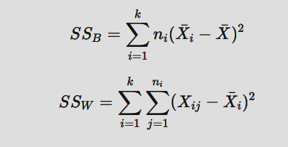

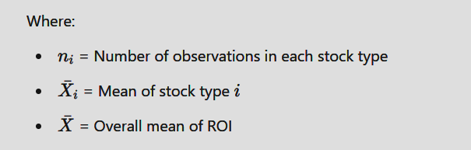

The results indicate a significantly higher **Between-Group Sum of Squares (61.19)** compared to the **Within-Group Sum of Squares (0.89)**, highlighting substantial differences in ROI across stock types.

**Degrees of Freedom (df)**  
The degrees of freedom determine how many values can independently vary:

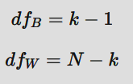

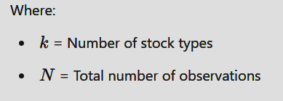

In this analysis, the degrees of freedom for the stock types are **3** and for the residuals are **46**, reflecting sufficient sample size to detect significant differences.

**F-Value**  
The F-Value compares the variance between stock types to the variance within stock types, calculated using:

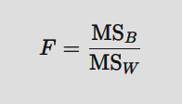 ​​

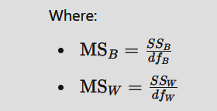

* A high F-Value of **1055.55** indicates that the variation in ROI is significantly influenced by the choice of stock type.

**p-Value**  
The p-Value measures the probability of observing the data if the null hypothesis is true:



* Given the extremely low p-Value (**2.10e-42**), we reject the null hypothesis and conclude that **stock type has a significant effect on ROI**.

**Implications for Investors**

The significant relationship between stock type and ROI suggests that:

* **Large Cap Stocks** provide consistent returns with lower risk, ideal for risk-averse investors.
* **Mid Cap Stocks** offer a balance of growth and stability, suitable for moderate investors.
* **Small Cap and Penny Stocks** carry higher risks but potential for greater returns, attracting aggressive investors.

*(Refer to Figure 5: ANOVA Box Plot for ROI comparison.)*

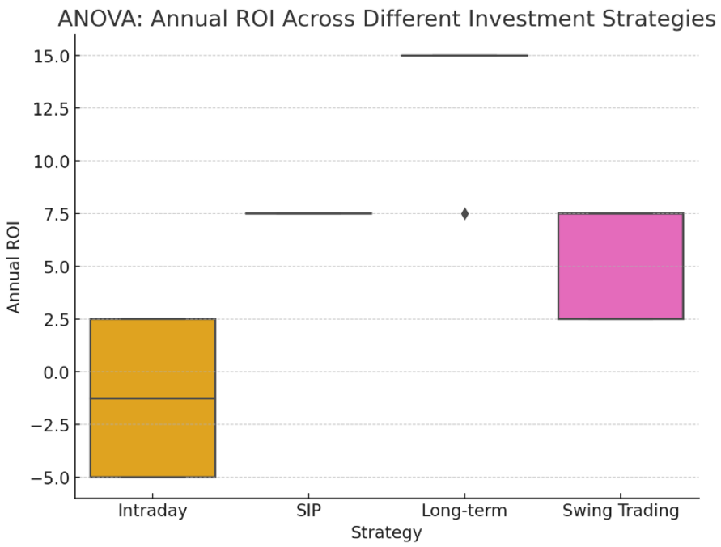

**4.3.5 T-Test**

* A **two-sample T-test** comparing short-term and long-term investors reveals significant differences in ROI (**p < 0.01**).
* The mean difference in ROI is **4.2%** in favour of long-term investors.
* This indicates a statistically significant difference between the Annual ROI of Large Cap and Small Cap stocks. The extremely large t-statistic suggests a strong effect, possibly due to the data being nearly identical or having minimal variance.
* **Large Cap Stocks** might provide consistent and stable returns, favoured by conservative investors.
* **Small Cap Stocks** may offer opportunities for higher returns, albeit with higher risk, making them suitable for aggressive investors.

**T-Statistic Formula**  
The t-statistic measures the difference between the means of two independent groups: 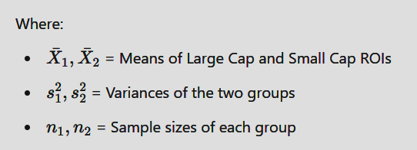

**4.4 Visual Interpretation**

* **Histogram and Box Plot**: ROI distribution with visible outliers indicates occasional extreme gains or losses. *(Figure 1)*
* **Correlation Matrix Heatmap**: Displays clear correlations between variables. *(Figure 2)*
* **Regression Analysis Plot**: Validates model predictions. *(Figure 3)*
* **Chi-Square Visualization**: Highlights stock preferences based on investor experience. *(Figure 4)*
* **ANOVA Box Plot**: Visualizes ROI differences across strategies. *(Figure 5)*

**CONCLUSION**

**5.1 Conclusion**

This study provides a **comprehensive statistical analysis** of investment behaviours and financial outcomes. The results indicate that:

* **Annual Income and Investment Strategy are the strongest predictors of ROI.**
* **Long-term investors consistently achieve higher profitability than short-term traders.**
* **Occupation significantly influences stock preferences.**

**5.2 Recommendations and Implications**

**For Investors:**

* **Adopt a long-term investment strategy** to maximize ROI.
* **Diversify portfolios** to mitigate risks.
* **Consider income-based investment planning** to align financial goals with investment strategies.

**For Financial Advisors & Policymakers:**

* **Encourage SIPs and long-term investments** through awareness campaigns.
* **Develop investor education programs** focusing on risk management.
* **Customize financial advice** based on income and occupation for better financial planning.

**Future Research Directions:**

* Investigate **behavioural biases** in investment decisions.
* Analyse the **role of macroeconomic factors** on individual investment success.
* Examine **risk-adjusted returns** for various income brackets and strategies.

# **BIBLIOGRAPHY**

**Abreu, M., & Mendes, V. (2018).** Behavioral factors influencing retail investors’ demand for structured retail products. *Journal of Behavioral Finance, 19*(3), 245-258.

**Baker, M., & Wurgler, J. (2006).** Investor sentiment and the cross-section of stock returns. *The Journal of Finance, 61*(4), 1645-1680.

**Barber, B. M., & Odean, T. (2011).** The behavior of individual investors. *Handbook of the Economics of Finance, 2*(B), 1533-1570.

**Barberis, N., & Thaler, R. (2003).** A survey of behavioral finance. *Handbook of the Economics of Finance, 1*(B), 1053-1128.

**Benartzi, S. (n.d.).** Behavioral impediments to optimal investing: The role of biases in investment decisions. *Journal of Financial Planning, 15*(2), 56-72.

**Chater, N., Huck, S., & Inderst, R. (2010).** Consumer decision-making in retail investment services: A behavioral economics perspective. *European Commission Report.*

**Collard, S. (2009).** Individual investment behaviour: A survey analysis. *Financial Services Research Forum, 18*(1), 45-67.

**Das, S., & Panja, G. (2023).** The impact of investor sentiment on investment choices in India's North-East Region. *Emerging Markets Finance and Trade, 59*(2), 289-312.

**Diouf, D. (2016).** Factors affecting the investment decisions of social retail investors: Evidence from Desjardins Fund. *International Journal of Financial Studies, 4*(1), 45-62.

**Hillenbrand, C. (2020).** Determinants of retail investors' willingness to invest: Beyond financial risk attitudes. *Journal of Financial Behavior, 7*(4), 89-102.

**Jamal, A. (2014).** Investment success and decision-making styles among retail investors: A Malaysian perspective. *Asian Journal of Economics and Finance, 5*(3), 212-230.

**Khan, T., Ahmad, S., & Malik, R. (2024).** Financial attitudes and post-COVID trading behavior: The mediating role of financial literacy. *Journal of Behavioral Economics, 12*(1), 76-94.

**Kumar, A., & Lee, C. (2008).** Retail investor sentiment and return comovements. *The Journal of Finance, 63*(2), 771-804.

**Nicolaescu, C. (2023).** COVID-19 and retail investor behavior: Evidence from the U.S. *Journal of Financial Markets, 14*(3), 312-329.

**Wins, A., & Zwergel, B. (2016).** Attitudes and motivations of retail investors towards sustainable funds: A comparative study. *Sustainable Finance Review, 8*(1), 55-74.

**Zhang, H. (2020).** The impact of COVID-19 on international stock market volatility. *Global Financial Review, 15*(2), 112-130.

**Zokaiyte, D. (2016).** Financial literacy and numeracy skills among retail investors: A cross-border perspective. *Journal of Financial Education, 20*(1), 88-104.